1. Excel Frequency Analysis (headcount)
2. Describe the sample’s demographics. Your description needs to include: 1) the total number of subjects; 2) numbers and/or percentages by gender; 3) numbers and/or percentages by grade; 4) numbers and/or percentages by race/ethnicities; and 5) numbers and/or percentages by schools.
3. How? Open Excel file. Copy all the demographic variables and paste them in a new data sheet. Select one of the abovementioned demographic variables. Choose “Insert” tab then click “PivotTable.” After a small window pops up, check “Existing worksheet” and choose a location (i.e. “G2”; it needs to be blank) on the data sheet. In the window shows up on the right hand side, drag the selected variable to the bottom of the window in both “ROWS” and “VALUES.” Repeat the process for all demographic variables.
4. You may present the required information in writing (paragraphs) or through a table (see the example included below).

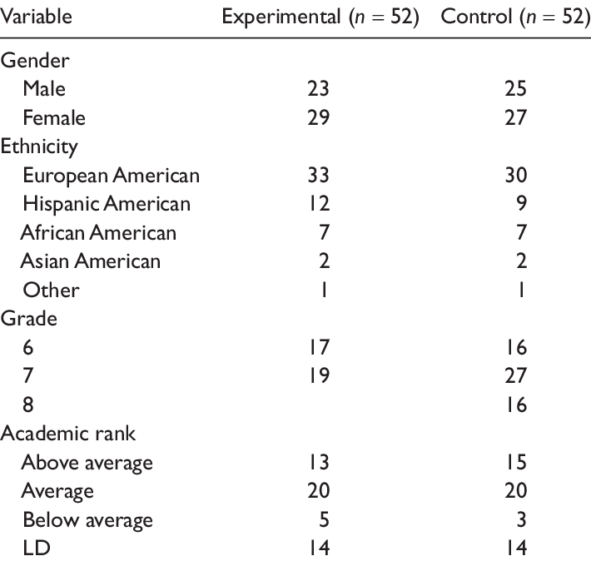

|  |  |
| --- | --- |
| Variables |  |
| Gender | 366 Total |
| Male | 110 |
| Female | 180 |
| No share | 76 |
| Grade |  |
| 6th | 46 |
| 7th | 242 |
| 8th | 144 |
| Ethnicities |  |
| Asian | 11 |
| AA | 178 |
| American Indian | 9 |
| Hispanic | 200 |
| Hawaiian | 5 |
| White | 378 |
| Mixed | 16 |
| Native |  |

1. ***Excel******Descriptive Analysis (Knowledge Total Score)***
2. Analyze the students’ knowledge test total score. Your description needs to report the students’ average score (mean), range of their scores, standardized deviation of their scores
3. **How?** Open Excel file. Copy the variable of “knowledge total score” to the second row in a new data sheet. Drag to the bottom of the data sheet. Key in “Mean” “Range” “Standardized Deviation” in the first row.

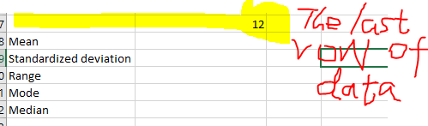

Below the last row of data, key in “ =AVERAGE(B2:B417)” then press Enter to get the mean. Then “=STDEVA(B2:B417)” to get standardized deviation. Then “Max(B2:B417)-Min(B2:B417)” to get the range. You may also use “Mode(B2:B417)” and “Median(B2:B417)” to get mode and median

1. “The sampled students had an average score of 5, on the total of 12 questions, their range was 12, the most often occurring number (Mode) was 6, and the median was 5.